Enterprise Network Implementation
Easy Study Notes — Lecture 12
This note explains how a company builds and connects its computer network. It covers small office networks, big campus networks, and how offices in different cities connect to each other (WAN). Diagrams are added to make each idea clear.

1. Small Office Network
A small office has only a few computers. So the network design is simple.
- It uses unmanaged 10/100 switches. These switches need no setup.
- It uses enhanced Cat 5 cables to connect computers to the switch.
All computers connect to one or two switches. The switches connect to each other. This makes a very basic and low-cost network.
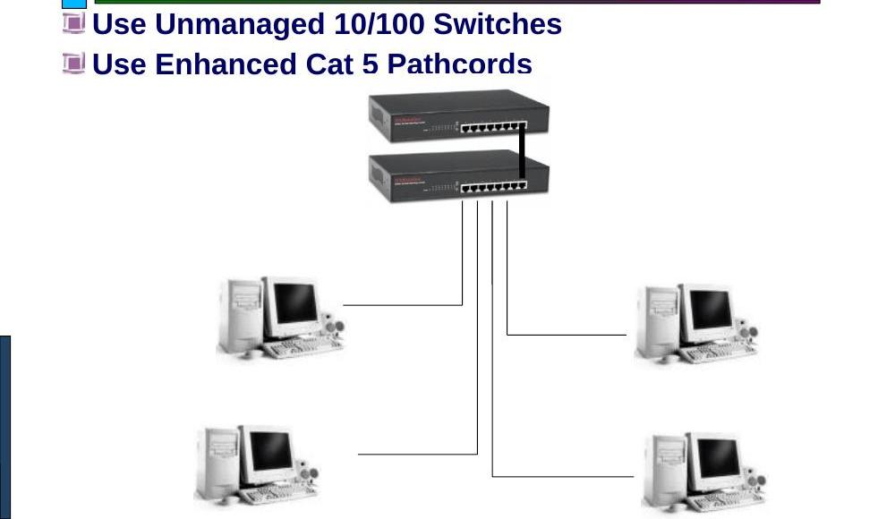
Figure 1: A small office network using unmanaged switches

2. Campus Network Architecture
A campus network connects many buildings in one location, like a college or a large company office. It uses a three-tier design. This design is also called Cisco's Switching Architecture. It has three layers of switches.

2.1 The Three Layers
- Backbone Switch — This is the top layer. It is a Layer 3/4 chassis-based switch. It has high-speed ports (100Fx, 1000Sx/Lx, or 10G) to connect to Distribution switches. It also connects to the Server Farm.
- Distribution Switch — This is the middle layer. It is a Layer 2/3 managed switch. It connects upward to the Backbone switch and downward to many Access switches.
- Access Switch — This is the bottom layer. It is a Layer 2 switch. Desktop computers connect directly to this switch.
The Server Farm holds the main servers. A Firewall sits between the Backbone switch and the Internet to give security.
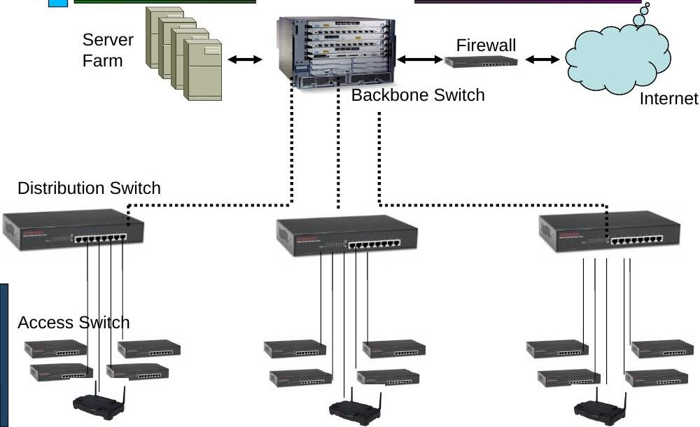
Figure 2: Three-tier campus network — Backbone, Distribution, and Access switches
Note: The three-tier design makes the network easy to expand. If more users join, we simply add more Access switches.

3. Campus Network Cabling
Different cable types are used to connect the switches, depending on distance and location.
- Campus backbone cabling — Single-mode or multimode fiber cable. It connects the main Backbone switch to each building's Distribution switch. A Ring architecture is used here, so if one path breaks, data can still travel the other way. This gives a backup route.
- Building backbone cabling — Category 5e or 6 UTP cable. It connects the building distributor to each floor distributor.
- Horizontal cabling — Also Category 5e or 6 UTP cable. It connects the floor distributor to each desktop.
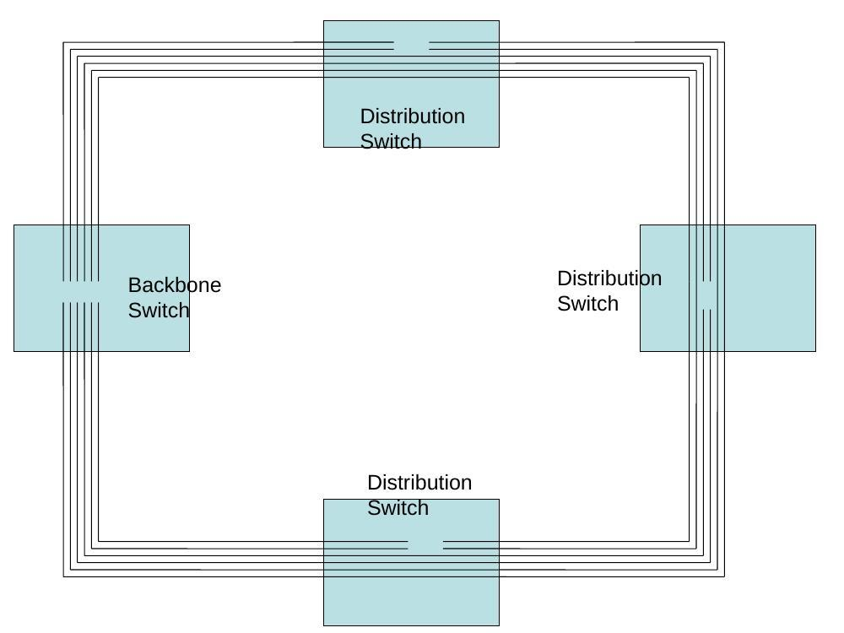
Figure 3: Ring cabling connects the Backbone switch to every Distribution switch, so there is always a backup path

3.1 Connecting to Homes and the Internet
- Home users can connect through Ethernet, Dial-up, or ADSL.
- The campus connects to the Internet through a leased line.

4. Enterprise WAN Architecture
A WAN (Wide Area Network) connects offices in different cities or countries. A company's Head Office connects to its Remote Offices, such as branch offices or retail counters.

4.1 Ways to Connect Remote Offices
- Leased Lines or IPLC (International Private Leased Circuit) — A dedicated, private line. Used by companies like Microsoft, IBM, and Cisco.
- VSAT (satellite link) — Used by banks for ATM networks and stock exchanges.
- VPN over the Internet — A secure tunnel over the public Internet. Cheaper than a leased line.
- A mix of the above methods.

4.2 Backup Links
If the main link fails, a backup keeps the office online.
- A second, alternate leased line.
- Dial backup using ISDN. The Head Office uses a PRI line, and Remote offices use a BRI line.

4.3 Other Parts of a WAN
- Disaster Recovery (DR) site — A backup site connected by multiple links, in case the main site fails.
- VoIP — A Call Manager at the Head Office lets all offices make calls over the network.
- NOC (Network Operation Center) — This team watches, manages, and maintains the whole network. It may sit at the Head Office or at a remote site.

5. Enterprise WAN Network Models
There are two common ways to link a Main Office to Remote and Regional Offices, Business Partners, Home Offices, and Mobile Workers.

5.1 Private Line Network Model
Each office connects to every other office using dedicated private lines. This gives a direct and secure path, but many private lines are costly.
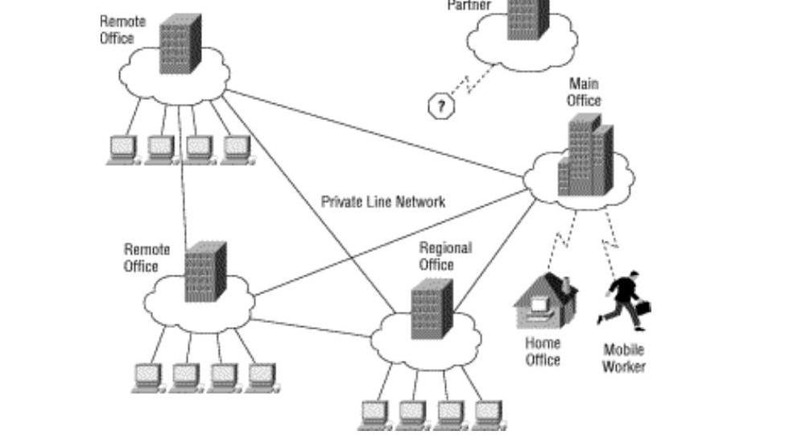
Figure 4: Offices linked directly through a Private Line Network

5.2 VPN Cloud Model
Here, all offices connect to one shared VPN Cloud (built over the Internet or IP network). The VPN Cloud passes the data between offices. This is cheaper than private lines for every single connection.
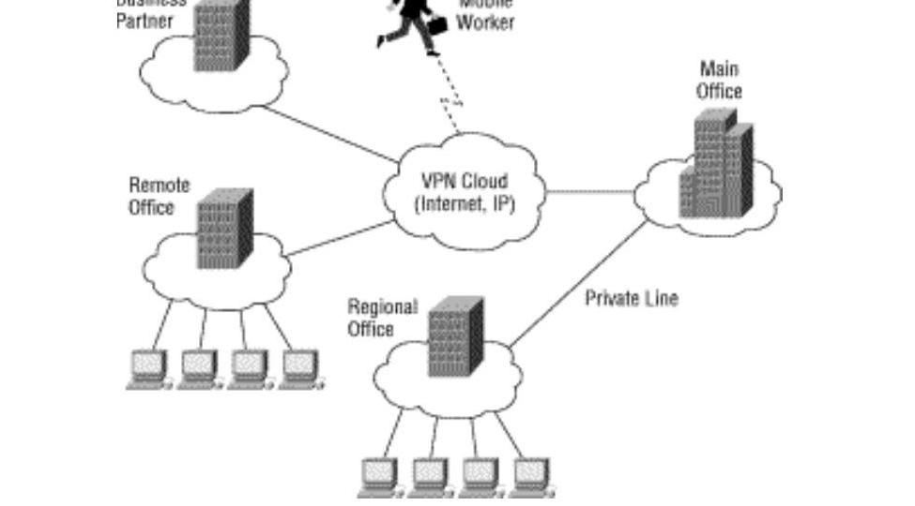
Figure 5: Offices linked through a shared VPN Cloud

5.3 Service Provider (MPLS) Model
In this model, the Corporate Head Office and all Branch Offices connect to one Service Provider Network. This network uses an MPLS Backbone (Multiprotocol Label Switching), which sends data quickly and reliably between all locations.
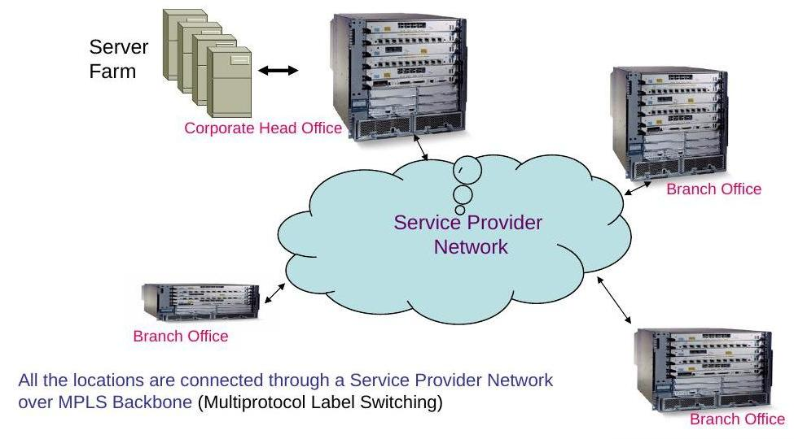
Figure 6: All offices connect through a Service Provider's MPLS backbone

6. Service Provider Networks
A Service Provider Network is the network of a big company (like an ISP) that carries data between many customers and cities.
- Customers connect to an ISP network.
- ISP networks connect to a large backbone network.
- Links between networks have limited bandwidth, so traffic must be managed well.
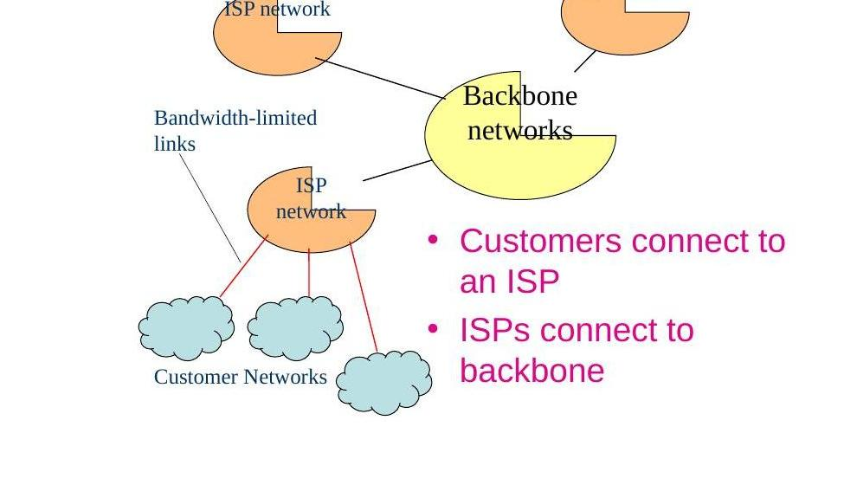
Figure 7: Customers connect to an ISP, and ISPs connect to the backbone

6.1 Case Study: Reliance
Reliance is one real example of a large Service Provider.
- Its data centers connect to more than 130 countries using an undersea fiber backbone (Flag Telecom) and other cable systems.
- Inside the country, Reliance has an optic fiber IP network reaching more than 1100 cities. Customers connect using leased lines, ISDN dial-up, or 3G mobile service.
- Reliance's data centers are joined in a redundant fiber ring for Disaster Recovery.
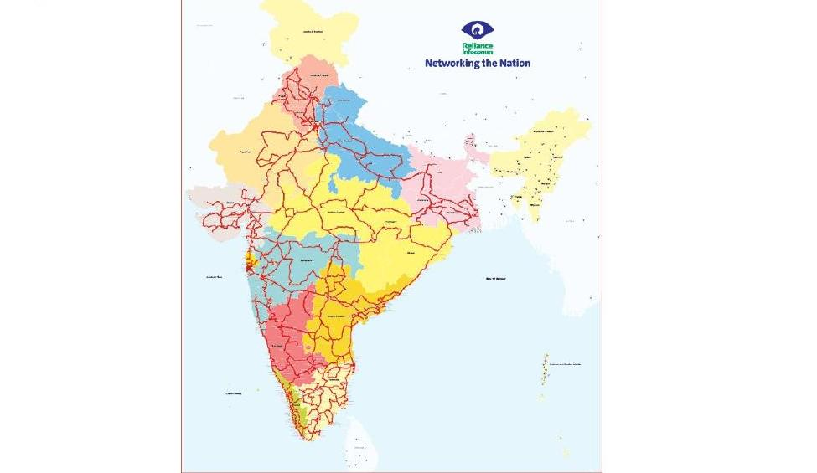
Figure 8: Reliance's domestic fiber network, reaching over 1100 cities in India
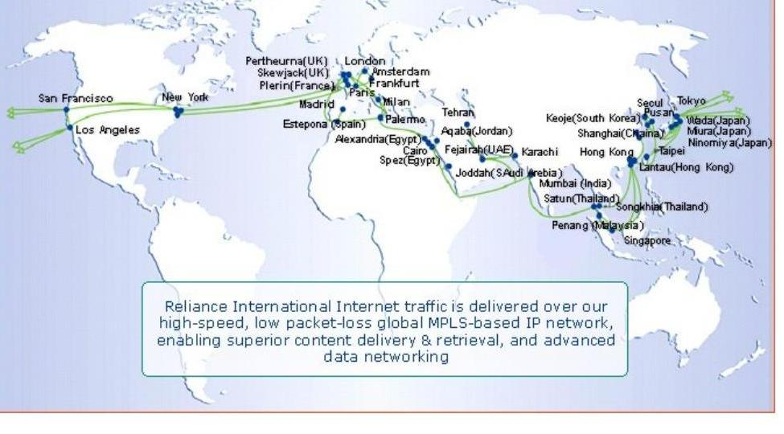
Figure 9: Reliance's global network links cities across many continents

6.2 Other Service Provider Example: FLAG
FLAG (Flag Telecom) is another well-known service provider. It is a global company that lays and manages undersea cables. These cables carry Internet traffic between countries, in the same way as Reliance's backbone does.

End of notes. Review the figures along with the bullet points above to remember each network layer and connection type easily.

